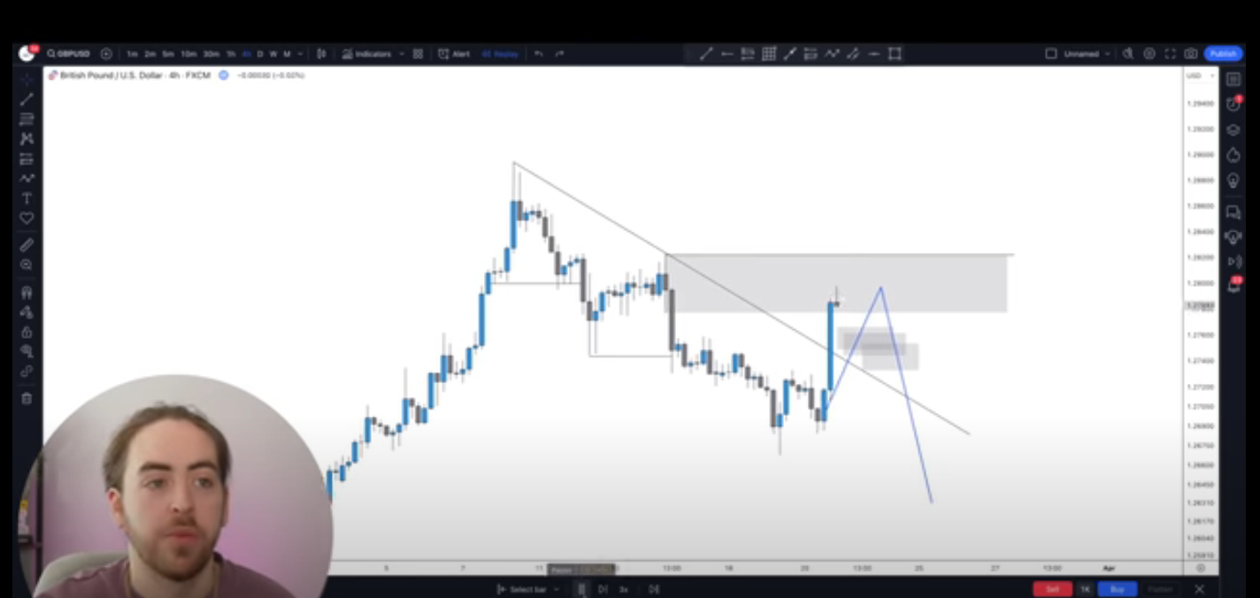

Liquidity stays above the Old highs and lows.

Liquidity + Position

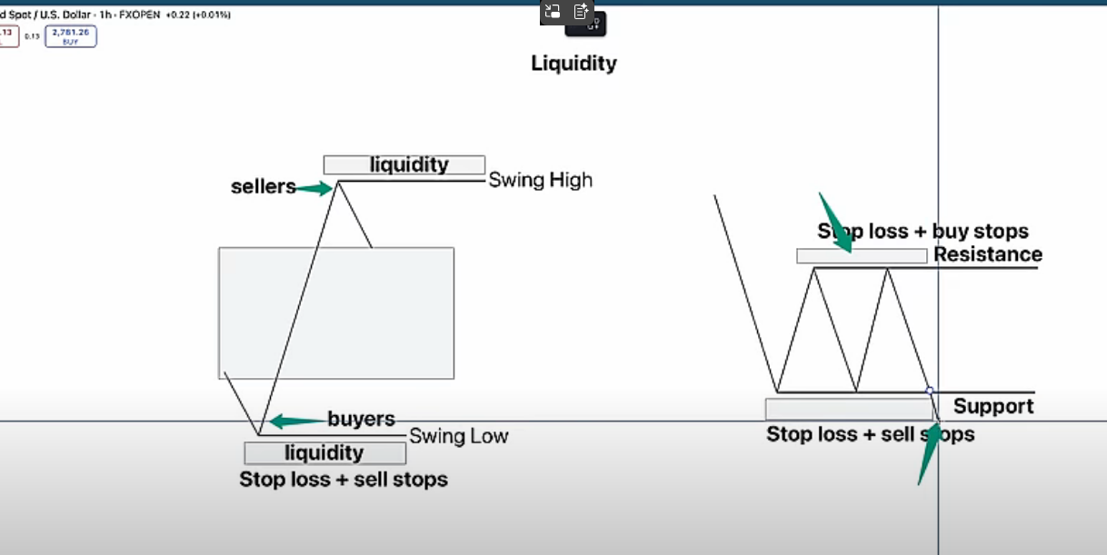

These are the areas that we are looking for and these are the ones that are going to be hunted down by the smart money. We place orders where this liquidity is grabbed.

Entry Model:

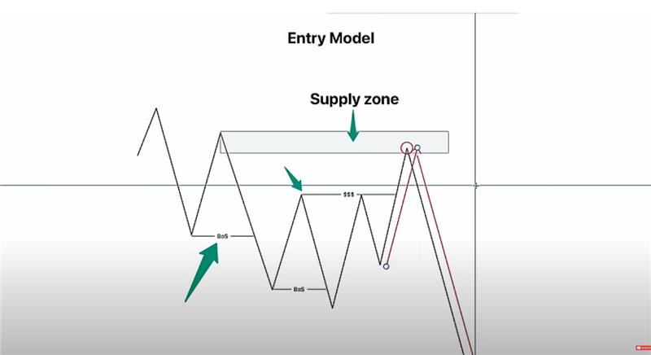

There will be small consolidation zones they will create equal highs or equal lows. And those are the areas that provide opportunities for liquidity grab, and then we place order from the supply zone.